Department of Electrical Engineering
The Superior University, Lahore

Computer Programming

Experiment No.12
Implementation of Recursive Functions

Prepared for:
Eisha Nawaz
By:
Name: Tanseer Haider
ID: SU91-BSEEM-F25-02
Section: Electrical Engineering Fall 25
Semester: 2nd

Total Marks: ______10_________
Obtained Marks: ______________
Signature: __________________
Date: __________________

Experiment No.12
Implementation of Recursive Functions
(Rubrics)

Name: Tanseer Haider ID: SU91-BSEEM-F25-02

- PSYCHOMOTOR
Serial No. | Criteria | Allocated Marks | Unacceptable  0% | Poor  25% | Fair  50% | Good  75% | Excellent  100% | Total Obtained
1 | Syntax handling | 1 | 0 | 0.25 | 0.5 | 0.75 | 1
2 | Program Coding Skills | 2 | 0 | 0.5 | 1 | 1.5 | 2
3 | Accuracy in Output Results | 3 | 0 | 0.75 | 1.5 | 2.25 | 3
Sub-Total |  | 6 | Sub Total Marks Obtained in Psychomotor (P)

- AFFECTIVE
Serial No. | Criteria | Allocated Marks | Unacceptable  0% | Poor  25% | Fair  50% | Good  75% | Excellent  100% | Total Obtained
1 | Assigned Tasks | 2 | 0 | 0.5 | 1 | 1.5 | 2
2 | Lab Report | 2 | 0 | 0.5 | 1 | 1.5 | 2
Sub-Total |  | 4 | Sub Total Marks Obtained in Affective (A)

Instructor Name: | Eisha Nawaz | Total Marks (P+A): | ____10______ _
Instructor Signature: | ______________ | Obtained Marks (P+A): | ______________

Contents of Lab 12
1 Objectives 4
2 Recursion in C++ 4
2.1.1 Example 7
2.1.2 Example: Code to Implement Fibonacci Series 8
2.1.3 Example : Factorial Program 9
3 Advantages and Disadvantages of Recursion 11
3.1 Advantages of C++ Recursion 11
3.2 Disadvantages of C++ Recursion 11
4 Lab Tasks 12
4.1 Task 1 12
4.2 Task 2 12
5 Home Assignment: 12
5.1 Task 1 12
5.2 Task 2 12

Implementation of Recursive Functions

Objectives
- Understand what recursion is and how a recursive function calls itself.
- Learn what a base case is and why every recursive function needs one.
- Trace how the call stack builds up and unwinds during a recursive call.
- Practice writing recursive functions for real, hands-on examples.
- Recognize and fix the most common recursion mistakes, including stack overflow.

1. What Is Recursion?
Recursion is when a function calls itself, either directly or indirectly, to solve a smaller version of the same problem. The function containing this self-call is called a recursive function.
Mathematical view: suppose you want the sum of the first n natural numbers. One way is to simply add them one by one: f(n) = 1 + 2 + 3 + ... + n. Another way is to define the sum in terms of a smaller version of itself:
f(n) = 1 when n = 1
f(n) = n + f(n-1) when n > 1

f(6) = 6 + f(5)
f(5)= 5 + f(4)
f(4)=4+f(3)
F(3)=3+f(2)
F(2)=2+f(1)
F(1)=1+f(0)
The second definition is recursive: f( ) is used inside its own definition. This is the essence of recursion — solve a big problem by reusing the solution to a smaller version of the same problem.

2. The Base Case
Every recursive function needs a base case — a condition simple enough to answer directly, without recursing any further. Without one, the function would call itself forever.
int fact(int n)
{
if (n <= 1) // base case
return 1;
else
return n * fact(n - 1);
}
ℹ Tip: The idea is always the same: express the problem in terms of one or more smaller versions of itself, then add a base case simple enough to stop the recursion outright.

3. Why Stack Overflow Happens
If the base case is missing, or is written so that it is never actually reached, the function keeps calling itself endlessly. Each call uses a little more memory (on what is called the call stack), and eventually the program runs out and crashes with a stack overflow error.
int fact(int n)
{
// wrong base case — may cause stack overflow
if (n == 100)
return 1;
else
return n * fact(n - 1);
}
If fact(10) is called, it calls fact(9), fact(8), fact(7), and so on — but n keeps decreasing, so it will never actually equal 100. The base case is never reached, and the recursion never stops.

4. Direct vs Indirect Recursion
Type | How It Works
Direct recursion | A function calls itself directly, e.g. funA() contains a call to funA().
Indirect recursion | A function calls another function, which eventually calls the first one again, e.g. funA() calls funB(), and funB() calls funA().
// direct recursion
void directRecFun()
{
// some code...
directRecFun();
}

// indirect recursion
void indirectRecFun1() { /* ... */ indirectRecFun2(); }
void indirectRecFun2() { /* ... */ indirectRecFun1(); }

5. How the Call Stack Works During Recursion
Every time a function is called (recursive or not), memory for it is allocated on the call stack, with its own separate copy of local variables. When the base case is reached, each call finishes and returns its value to whoever called it, in reverse order — like unstacking a pile of plates from the top down.
#include <iostream>
using namespace std;

void printFun(int test)
{
if (test < 1)
return;
else
{
cout << test << " ";
printFun(test - 1); // recursive call
cout << test << " ";
}
}

int main()
{
printFun(3);
return 0;
}
Output
3 2 1 1 2 3
Dry run — note how the second print (after the recursive call) only happens as each call unwinds, in reverse order:
Step | Call | Action
1 | printFun(3) | Prints “3”, then calls printFun(2)
2 | printFun(2) | Prints “2”, then calls printFun(1)
3 | printFun(1) | Prints “1”, then calls printFun(0)
4 | printFun(0) | Base case (test < 1): returns immediately, nothing printed
5 | printFun(1) resumes | Prints “1” again, then returns
6 | printFun(2) resumes | Prints “2” again, then returns
7 | printFun(3) resumes | Prints “3” again, then returns

6. Worked Example — Fibonacci Series
The Fibonacci sequence is a classic example where a function calls itself twice. Each number is the sum of the two numbers before it.
fib(n) = n when n = 0 or n = 1
fib(n) = fib(n-1) + fib(n-2) otherwise
#include <iostream>
using namespace std;

int fib(int n)
{
if (n == 0) return 0;
if (n == 1 || n == 2) return 1;
return fib(n - 1) + fib(n - 2);
}

int main()
{
int n = 5;
cout << "Fibonacci series of 5 numbers is: ";
for (int i = 0; i < n; i++)
cout << fib(i) << " ";
return 0;
}
Output
Fibonacci series of 5 numbers is: 0 1 1 2 3
ℹ Tip: Functions like this, with two recursive calls instead of one, branch out into a tree of calls rather than a single chain — which is why Fibonacci written this way gets noticeably slower for larger n.

7. Worked Example — Factorial
#include <iostream>
using namespace std;

int factorial(int n)
{
if (n > 1)
return n * factorial(n - 1);
else
return 1;
}

int main()
{
int n = 4;
cout << "Factorial of " << n << " = " << factorial(n);
return 0;
}
Output
Factorial of 4 = 24
Each call reduces n by 1 until n is no longer greater than 1, at which point the base case returns 1 and every pending multiplication is carried out on the way back up the stack.

8. Advantages and Disadvantages of Recursion
Advantages | Disadvantages
Makes code shorter and cleaner for naturally repetitive problems. | Uses a lot more stack space than an equivalent loop.
Essential for tree/graph traversal and similar data-structure problems. | Uses more processor time due to repeated function calls.
Often mirrors the mathematical definition of the problem directly. | Can be harder to trace and debug than an iterative version.

9. Common Mistakes to Avoid
Common Mistake | Why / Fix
Forgetting the base case entirely. | Every recursive function needs at least one condition that returns without recursing further.
Writing a base case that can never actually be reached (e.g. checking n == 100 when n only decreases from 10). | Make sure the recursive step moves steadily toward the base case's exact condition.
Calling the function with the same arguments instead of a smaller sub-problem (e.g. forgetting to write n - 1). | Double check that each recursive call is working on a strictly smaller version of the problem.
Expecting a function with two recursive calls (like Fibonacci) to be as fast as a loop. | This is a real trade-off of recursion — not a bug, but worth knowing about for large inputs.

10. Solved Practice Problem — Sum of Digits
Problem: Write a recursive function that adds up the digits of a positive integer (e.g. the digits of 134 sum to 1 + 3 + 4 = 8).
#include <iostream>
using namespace std;

int sumOfDigits(int n)
{
if (n == 0) // base case
return 0;
return (n % 10) + sumOfDigits(n / 10);
}

int main()
{
int number = 134;
cout << "Sum of digits of " << number << " = " << sumOfDigits(number);
return 0;
}
Output
Sum of digits of 134 = 8
Dry run:
Step | Call | n % 10 | Action
1 | sumOfDigits(134) | 4 | Calls sumOfDigits(13), will add 4 to its result
2 | sumOfDigits(13) | 3 | Calls sumOfDigits(1), will add 3 to its result
3 | sumOfDigits(1) | 1 | Calls sumOfDigits(0), will add 1 to its result
4 | sumOfDigits(0) | — | Base case: returns 0
5 | sumOfDigits(1) resumes | — | Returns 1 + 0 = 1
6 | sumOfDigits(13) resumes | — | Returns 3 + 1 = 4
7 | sumOfDigits(134) resumes | — | Returns 4 + 4 = 8 (final answer)

Working of Factorial Program
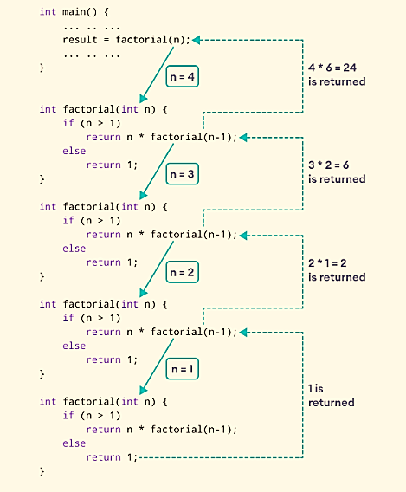
As we can see, the factorial() function is calling itself. However, during each call, we have decreased the value of n by 1. When n is less than 1, the factorial() function ultimately returns the output.

Advantages and Disadvantages of Recursion
Below are the pros and cons of using recursion in C++.

Advantages of C++ Recursion
It makes our code shorter and cleaner.
Recursion is required in problems concerning data structures and advanced algorithms, such as Graph and Tree Traversal.

Disadvantages of C++ Recursion
It takes a lot of stack space compared to an iterative program.
It uses more processor time.
It can be more difficult to debug compared to an equivalent iterative program

Lab Tasks
Digital Logic Recursive Toolkit
Scenario: Digital circuits work in binary, and it is common to need a decimal value converted to binary and to know how many bits it needs.

(a) Basic Recursive Function
Write void printBinary(int n) that recursively prints the binary representation of n (base case: n == 0 returns without printing; otherwise call printBinary(n / 2) first, then print n % 2). Test with n = 13.
#include <iostream>
using namespace std;

// TODO: write void printBinary(int n)

int main()
{
int n = 13;
cout << "Binary of " << n << " is: ";
// TODO: call printBinary(n)
return 0;
}
Expected Output
Binary of 13 is: 1101

(b) Recursion Over an Array
Write int sumOfCurrents(int currents[], int size) that recursively adds up an array of current readings (base case: size == 0 returns 0). Test with currents = {120, 85, 60, 45}.
Expected Output
Total current: 310 mA

(c) Dry Run — Trace the Call Stack
Trace printBinary(13) step by step, the same way Section 5 traced printFun(3).
Step | Call | Action
1 | printBinary(13) | Calls printBinary(6) first (nothing printed yet)
2 | printBinary(6) | Calls printBinary(3) first
3 | printBinary(3) | Calls printBinary(1) first
4 | printBinary(1) | Calls printBinary(0) first
5 | printBinary(0) | Base case reached, returns immediately
6 | printBinary(1) resumes | Prints 1 % 2 = 1
7 | printBinary(3) resumes | Prints 3 % 2 = 1
8 | printBinary(6) resumes | Prints 6 % 2 = 0
9 | printBinary(13) resumes | Prints 13 % 2 = 1 → final printed sequence: 1101

(d) Find and Fix the Bug
The function below is meant to count how many bits are needed to represent n, but it is missing something important. Find the bug and fix it.
int countBits(int n)
{
// BUG: no base case!
return 1 + countBits(n / 2);
}
⚠ Bug: Without a base case, n keeps getting divided by 2 forever (or rather, it eventually gets stuck at 0 and never stops calling itself). Add if (n == 0) return 0; before the recursive line.
Expected Output After Fixing (n = 13)
Number of bits: 4

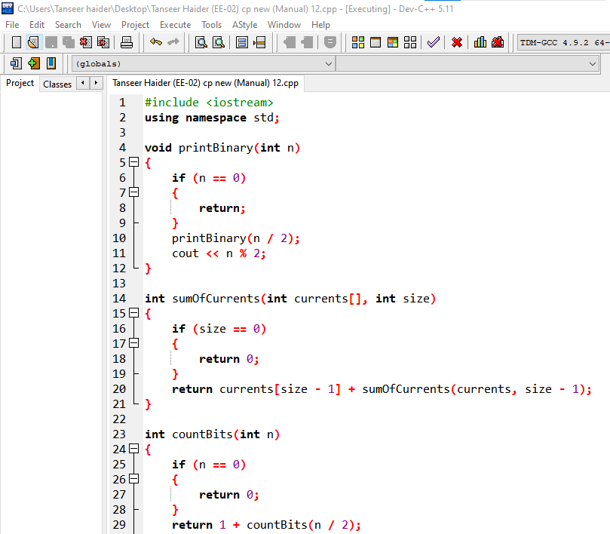

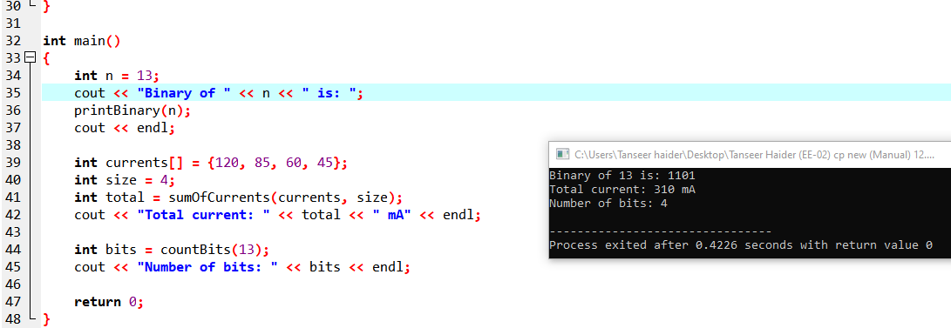

4 Home Assignment:
Recursive Signal Attenuation Calculator
Scenario: A signal loses a fixed percentage of its strength at each relay stage it passes through.

(a) Basic Recursive Function
Write float signalAfterStages(float initial, float retention, int stages) that recursively multiplies the signal by retention once per stage (base case: stages == 0 returns initial). Test with initial = 100, retention = 0.9, stages = 3.
Expected Output
Signal strength after 3 stages: 72.9

(b) Recursion Over an Array
Write float totalLossAcrossRelays(float losses[], int size) that recursively sums an array of loss values in dB. Test with losses = {2.5, 3.0, 1.8, 2.2}.
Expected Output
Total signal loss: 9.5 dB

(c) Dry Run — Trace the Call Stack
Step | Call | Action
1 | signalAfterStages(100, 0.9, 3) | Calls signalAfterStages(100, 0.9, 2) first
2 | signalAfterStages(100, 0.9, 2) | Calls signalAfterStages(100, 0.9, 1) first
3 | signalAfterStages(100, 0.9, 1) | Calls signalAfterStages(100, 0.9, 0) first
4 | signalAfterStages(100, 0.9, 0) | Base case: returns 100
5 | stages = 1 resumes | Returns 100 x 0.9 = 90
6 | stages = 2 resumes | Returns 90 x 0.9 = 81
7 | stages = 3 resumes | Returns 81 x 0.9 = 72.9 (final answer)

(d) Find and Fix the Bug
void listStages(int stage)
{
if (stage == 0) return;
cout << "Stage " << stage << endl;
listStages(stage); // BUG: should move toward the base case!
}
Bug: The recursive call passes stage unchanged, so it never gets closer to 0. It should be listStages(stage - 1);
Expected Output After Fixing (listStages(3))
Stage 3
Stage 2
Stage 1

